Transformer Design

We use 495-5251-ND as a core. Its material is N41.

Bsat is nearly 0.4T.

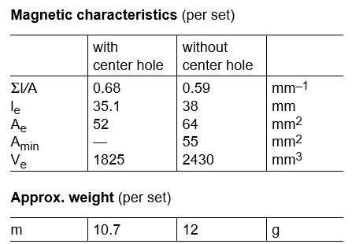

(1)

From the equation (1) N1>2

%%% (2)

%%%R=0.2 Ω

Inductance factor of the core is 1.6 µH. In order to have less ripple than 40% on magnetizing inductance current(from part a), N1 should be 2.17, at least. For N1=3, Lm is equal to

N1=3, N2=12 is chosen.

